<page_start no = 1>
<sol_start id=1>
1. (3) 3
<sol_end>

<sol_start id=2>
2. (3) tan 60°
<sol_end>

<sol_start id=3>
3. (2) 30°
<sol_end>

<sol_start id=4>
4. (1) 10 cm
<sol_end>

<sol_start id=5>
5. (4) a = 0
<sol_end>

<sol_start id=6>
6. (4) Four decimal places
<sol_end>

<sol_start id=7>
7. (3) 3 and I
<sol_end>

<sol_start id=8>
8. (2) (0, –1)
<sol_end>

<sol_start id=9>
9. (4) No solution
<sol_end>

<sol_start id=10>
10. (1) k = –9/2
<sol_end>

<sol_start id=11>
11. (1) k ≠ –3
<sol_end>

<sol_start id=12>
12. (1) 8
<sol_end>

<sol_start id=13>
13. (1) similar
<sol_end>

<sol_start id=14>
14. (1) x²y⁴z⁴
<sol_end>

<sol_start id=15>
15. (3) x²/2 –x/2 –6
<sol_end>

<sol_start id=16>
16. (3) intersecting or coincident
<sol_end>

<sol_start id=17>
17. (1) Parallel
<sol_end>

<sol_start id=18>
18. (4) 16 : 81
<sol_end>

<sol_start id=19>
19. (3) Assertion (A) is true but Reason (R) is false
<sol_end>

<sol_start id=20>
20. (1) Both A and R are true and R is correct explanation of A
<sol_end>
<page_end>

<page_start no =2>
<sol_start id=21>
21. 6 × 5 × 4 × 3 × 2 × 1 + 5 ⇒ 6 × 4 × 3 × 2 × 1 × 5(1 + 1)
= 6 × 4 × 3 × 2 × 1 × (2) × 5
Since it has more than two factors it is composite.
<sol_end>

<sol_start id=22>
22. 4x + 6y = 7 ⇒ 4x + 6y – 7 = 0 (a₁x + b₁y + c₁ = 0)
kx + 18y = 21 ⇒ kx + 18y – 21 = 0 (a₂x + b₂y + c₂ = 0)
for infinite solutions
So,
∴ Value of k is 12.
<sol_end>

<sol_start id=23>
23. origin (0, 0) and point 2 is (–6, 8)
By Distance formula =
= 10
So, distance is 10 units.
<sol_end>

<sol_start id=24>
24. Given : sin 3A = cos (A – 10°)
we know that sin θ = cos (90 – θ)
So, sin 3A cos (90 – 3A)
90 – 3A = A – 10 (from given)
100 = 4A ⇒ A = 25° and 3A = 75°
So, 3A is an acute angle.
<sol_end>
<page_end>

<page_start no = 3>
<sol_start id=25>
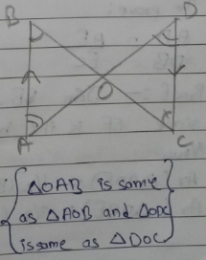
25. Given : AB || CD
∠B = ∠C (Alternate Angle)
∠A = ∠D (Alternate Angle)
Proved above information for ΔOAB and ΔODC
By AA rule
∴ ΔAOB ~ ΔDOC
<sol_end>

<sol_start id=26>
26.
= 2 cosec θ {1/sin θ = cosec θ}
Hence proved
<sol_end>
<page_end>

<page_start no =4>
<sol_start id=27>
27. Base proportionality theorem states that, if a line is parallel to a side of a triangle which intersects the other sides into two distinct points, then the line divides those sides in proportion for that triangle.
Let ΔABC, where line l is parallel to BC, intersect AB at and AC at E
To prove :
Proof : - Join BE, CD and Draw EF ⊥ AB, DG ⊥ CA
Since EF is the height of ΔADE and ΔDBE
Now,
Ar (ΔADE) = ½ (Base × Height) ½ × AD × EF
Ar (ΔDBE) = ½ (Base × Height) ½ × DB × EF
…..(i)
Also,
…..(ii)
But ΔDBE and ΔDCE are on the some base DE and between the same parallel
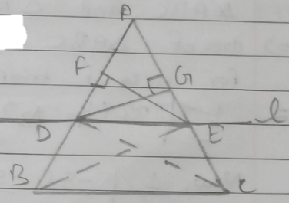
∴ ar(ΔDBE) = ar(ΔDCE) ……(iii)
From (i), (ii) and (iii) we have
Hence proved
<sol_end>

<sol_start id=28>
28. let Sagar age be x and Tiru age be y
Given
x – 5 = 2(y – 5) …..(i)
x + 10 – (y + 10) = 10 …..(ii)
So, x – 5 = 2y – 10 ⇒ x – 2y = –5
x + 10 – y – 10 = 10 ⇒ x – y = 10
New, By elimination
x – 2y = –5
– x – y = 10
–y = –15 ⇒ y = 15
Now, x – 2(15) = –5 = x – 30 – 5 ⇒ x = 25
So, age of Sagar is 25 year
Age of Tiru is 15 years
When Tiru have borned Saga’s age was 10 years.
<sol_end>
<page_end>

<page_start no =5>
<sol_start id=29>
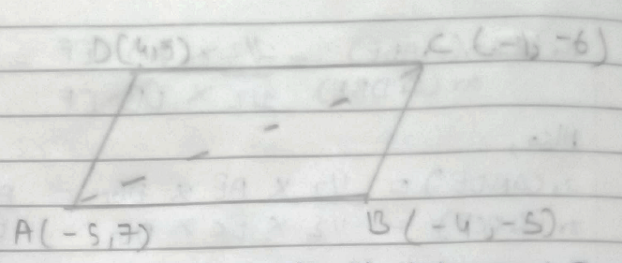
29. Given
A (–5, 7)
B (–4, –5)
C (–1, –6)
D (4, 5)
To find its area we will spilt it into 2 triangles ΔABC and ΔACD
⇒ area of ΔABC
For area of triangle we have :-
=
Now,
= 17.5 units square
Now for ΔACD
= 54.5 units square
So, Total area is 72 sq units.
<sol_end>

<sol_start id=30>
30. MCF of 861 and 1353 –
1353 = 861 × 1 + 492
861 = 492 × 1 + 369
392 = 369 × 1 + 123
369 = 123 × 3 + 0
So, HCF of 861 and 1353 is 123.
<sol_end>
<page_end>

<page_start no =6>
<sol_start id=31>
31. A point of x-axis means y-co-ordinate is 0
So, it is in form of (x, 0)
Given
Distance of (x, 0) from (5, –2) and (–3, 2) is equal
By distance formulas
⇒ (5 – x)² + 4 (–3 – x)² + 4
⇒ (5 – x)² = (–3 – x)²
⇒ 25 + x² – 10x = a + x² + 6x
= 16 = 16x ⇒ x = 1
So, value of x is 1
<sol_end>

<sol_start id=32>
32. tan A + sin A = m
tan A – sin A = n
m² = (tan A + sin A)² = tan² A + sin² A + 2sin A tan A
n² = (tan A + sin A)² = (tan² A + sin A – 2 sin A tan A
m² – n² = (tan A + sin A)² – (tan A – sin A)²
= 4 sin A tan A ……(i)
Now, mn = (tan A + sin A) (tan A – sin A)
= tan2 A – sin2A
= sin² A/cos² A –sin² A =
{1 – cos²θ = sin²θ}
= mn and root mn = ……(ii)
From (i)
sin A ∙ tan A = sin A × sin A/cos A = sin²A/cos A …..(ii)
So, LHS
= 4 sin A ∙ tan A ⇒ from (iii)
Hence proved
<sol_end>
<page_end>

<page_start no =7>
<sol_start id=33>
33. Given
x – y + 1 = 0 ……(i)
3x + 2y – 12 = 0 ……(ii)
Now,
x – y = –1 and 3x + 2y = 12
for the (i) equation.
x = –1 + y ⇒ x = y – 1
x | –1 | 0 | 1 | 2 | 3
y | 0 | 1 | 2 | 3 | 4

For the (ii) equation
3x + 2y = 12 ⇒ 3x = 12 – 2y ⇒ x = 4 – 2/3y
x | 4 | 10/3 | 8/3 | 2
Y | 0 | 1 | 2 | 3

x, y intersects at 2, 3
Points on x – axis are : (–1, 0) and (4, 0)
So the area of triangle formed by it is :-
Area of triangle formed by intersection and x-axis is 7.5 sq units.
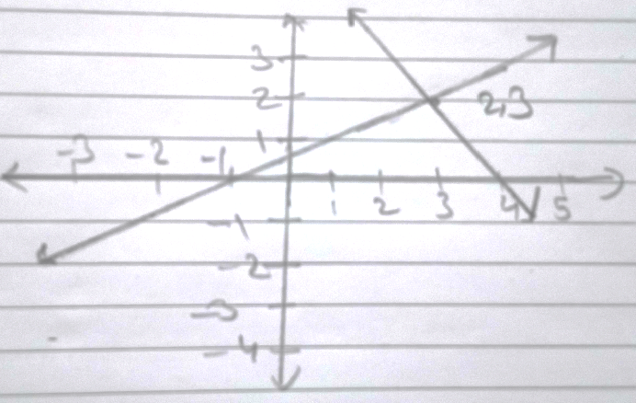
<sol_end>

<sol_start id=34>
34. Given :
Polynomial = (2x³ – 4x – x² + 2)
Two zeros are and
So,
we and write
and as they are zero/roots
Now,
Now,
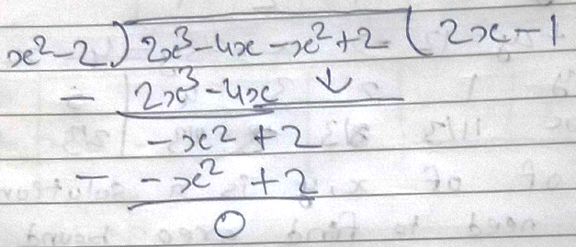
So, (2x – 1) = 2x³ – 4x – x² + 2
Now, 2x – 1 = 0 ⇒ 1 = 2x ⇒ ½ = x
Therefore its all zeros are
Since it has degree of 3 it have 3 zeros.
<sol_end>
<page_end>

<page_start no =8>
<sol_start id=35>
35. Given :
Point A = (4, –3)
Point B = (8, 5)
Ratio is which they divide 3 : 1
We need to find Point C (Point, which divides the line segment in 3 : 1)
So,
By Section formula
= C (x, y)
m₁ = 3, m₂ = 1, x₁ = 4, x₂ = 8, y₁ = –3, y₂ = 5
Now,
= Point C (x, y)
= C (x, y)
= [7, 3] = C (x, y)
So the co-oridnates for C are (7, 3)
<sol_end>

<sol_start id=36>
<sub_id = 1>
36.(i) (2) (0, 12)
<sub_id end>
<sub_id = 2>
(ii) (1) (3, 5)
<sub_id end>
<sub_id = 3>
(iii) (3) 5m
<sub_id end>
<sol_end>

<sol_start id=37>
<sub_id = 1>
37. (i) (3) Parabola
<sub_id end>
<sub_id = 2>
(ii) (3) 0
<sub_id end>
<sub_id = 3>
(iii) (3) –3, 2
<sub_id end>
<sol_end>
<sol_start id=38>
<sub_id = 1>
38. (i) (3) 24 cm²
<sub_id end>
<sub_id = 2>
(ii) (1) RHS
<sub_id end>
<sub_id = 3>
(iii) (4) Converse of Pythagoras Theorem
<sub_id end>
<sol_end>
<page_end>

